

|  |  |
| --- | --- |
| **ASSIGNMENT** | |
| **Course Code** | ECC201A |
| **Course Name** | SIGNALS AND SYSTEMS |
| **Programme** | BTECH |
| **Department** | ELECTRICAL ENGINEERING |
| **Faculty** | FET |

#### 

|  |  |
| --- | --- |
| **Name of the Student** | NITHESH KUMAR N |
| **Reg. No** | 17ETEE003026 |
| **Semester/Year** | 3SEM / 2YEAR |
| **Course Leader/s** | Mr. VISHWANATH K REDDY |

|  |  |  |  |  |  |  |  |  |
| --- | --- | --- | --- | --- | --- | --- | --- | --- |
| **Declaration Sheet** | | | | | | | | |
| Student Name | NITHESH KUMAR N | | | | | | | |
| Reg. No | 17ETEE003026 | | | | | | | |
| Programme | BTECH | | | | | Semester/Year | 3 SEM / 2 YEAR | |
| Course Code | ECC201A | | | | | | | |
| Course Title | SIGNALS AND SYSTEMS | | | | | | | |
| Course Date |  | | to | |  | | | |
| Course Leader | MR. VISHWANATH K REDDY | | | | | | | |
| **Declaration**  The assignment submitted herewith is a result of my own investigations and that I have conformed to the guidelines against plagiarism as laid out in the Student Handbook. All sections of the text and results, which have been obtained from other sources, are fully referenced. I understand that cheating and plagiarism constitute a breach of University regulations and will be dealt with accordingly. | | | | | | | | |
| Signature of the Student | |  | | | | | Date |  |
| Submission date stamp  (by Examination & Assessment Section) | |  | | | | | | |
| Signature of the Course Leader and date | | | | Signature of the Reviewer and date | | | | |
|  | | | |  | | | | |



**Faculty of Engineering and Technology**

**Ramaiah University of Applied Sciences**

|  |  |  |  |
| --- | --- | --- | --- |
| Department | Electrical and Electronics Engineering | Programme | B. Tech. in Electrical |
|  |  |  | Engineering |
| Semester/Batch | 3rd/2017 |  |  |
| Course Code | ECC201A | Course Title | Signals and Systems |
|  |  |  |  |
| Course Leader(s) | Mr. Viswanath K. Reddy |  |  |
|  |  |  |  |



**Assignment – 01**

**Reg.No.**

|  |
| --- |
| **Sections** |

**Name of Student**

**Marking Scheme**

|  |
| --- |
| **Marks Max** |

**Marks**

**First**

**Examiner** **Moderator**

**Marks**

|  |
| --- |
| **Part B.1 Part A** |

|  |
| --- |
| **Part B.2** |

|  |  |  |  |  |
| --- | --- | --- | --- | --- |
|  |  |  |  |  |
| A | Essay on Sparse sensing | 5 |  |  |
|  |  |  |  |  |
|  | **Part-A Max Marks** | **5** |  |  |
|  |  |  |  |  |
| B **1.1** | Generation and plotting the given input signals | 2 |  |  |
|  |  |  |
|  |  |  |  |  |
| B **1.2** | Computation and plotting of 1( ), 2( ) and 3( ) | 4 |  |  |
|  |  |  |  |  |
| B **1.3** | Computation and plotting of 4( ) | 4 |  |  |
|  |  |  |  |  |
|  | **B.1 Max Marks** | **10** |  |  |
|  |  |  |  |
|  |  |  |  |  |
|  |  |  |  |  |
| B **2.1** | Computation and plotting the modulated signal | 4 |  |  |
|  |  |  |
|  |  |  |  |  |
| B **2.2** | Computation and plotting the received signal | 4 |  |  |
|  |  |  |  |
|  |  |  |  |  |
| B **2.3** | Comparison and comment on the energy of the message |  |  |  |
|  | and received signals | 2 |  |  |
|  |  |  |  |
|  |  |  |  |  |
|  | **B.2 Max Marks** | **10** |  |  |
|  |  |  |  |
|  |  |  |  |  |

**Total Assignment Marks** **25**

**Course Marks Tabulation**

|  |  |  |  |  |
| --- | --- | --- | --- | --- |
| **Component-1 (B)** | **First** | **Remarks** | **Moderator** | **Remarks** |
| **Assignment** | **Examiner** |
|  |  |  |
| A |  |  |  |  |
|  |  |  |  |  |
| B.1 |  |  |  |  |
|  |  |  |  |  |
| B.2 |  |  |  |  |
|  |  |  |  |  |
| **Marks (Max 25 )** |  |  |  |  |
|  |  |  |  |  |



**Signature of First Examiner** **Signature of Moderator**

1

# **Question No. A**

**Solution to Question No. A:**

## Importance of Sparse sensing in signal processing:

Sparce sensing is the new technology which is recently done for efficient way of signal processing. Signal processing is done to study natural signals which cannot be studied directly hence processing is done first processing would be sampling the signals to discrete values for the respected continuous signal then the signals are quantized to some value according to the nyquist law. This discrete samples which are quantizesd are further processed in signal processing the study is done on that wave. After stabilizing the wave the wave is reconstructed. Dequantization of descrete waves are done first the signals are not converted into continuous signal directly after signal process since there will be alteration or losses in the wave hence the waves are first dequantised to get a time varying discrete signal then the given signal is reconstructed. But in modern days sparce sensing is given more scope in synthesizing the wave here the wave is compressed to certain time period by this there would be less number of discrete signals and we get a compressed discrete signals

# **Question No. B**

**Solution to Question No. B:**

**Values:** x1(t)=u(t), x2(t)=r(t), a1=12, a2=4, a3=3, b1=6, b2=1.

## B1.1 Generate and plot the given input signals 𝑥1(𝑡) and 𝑥2(𝑡):

Programme in matlab :

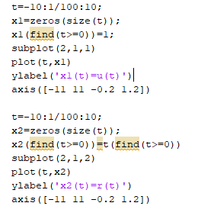

## Output signal:

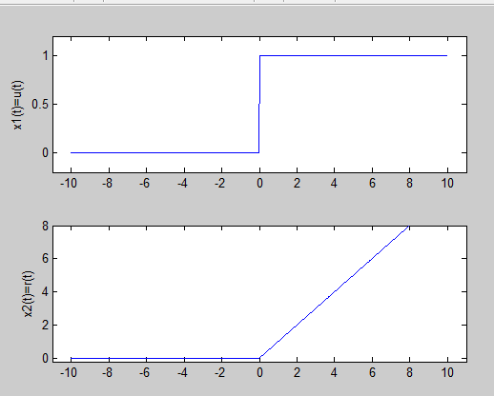

For verification purpose:

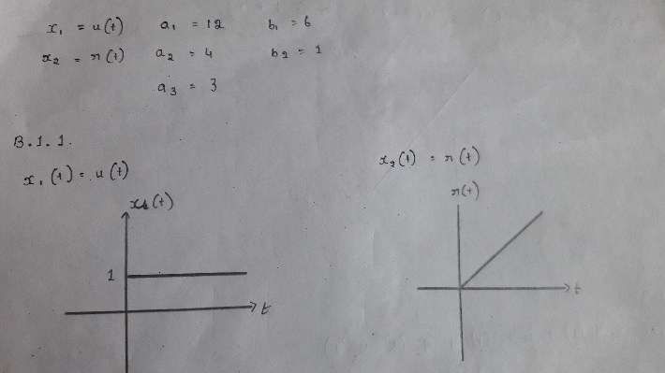

## B1.2 Compute and plot the signals 𝑦1(𝑡),𝑦2(𝑡) and 𝑦3(𝑡):

Program:

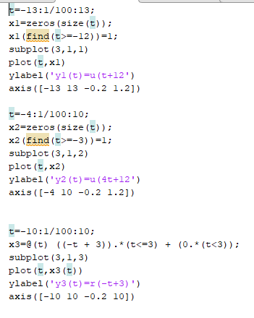

**Graph:**

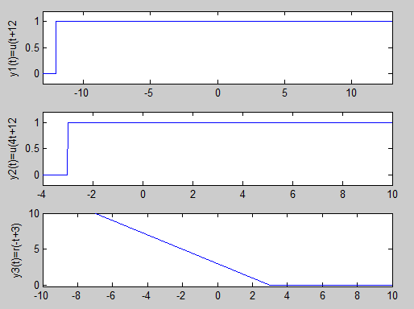

**For verification purpose:**

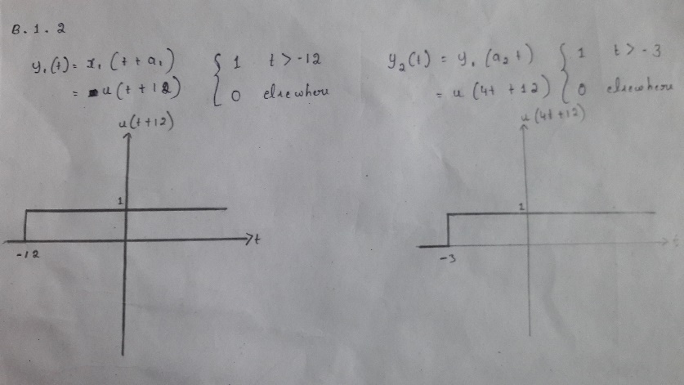

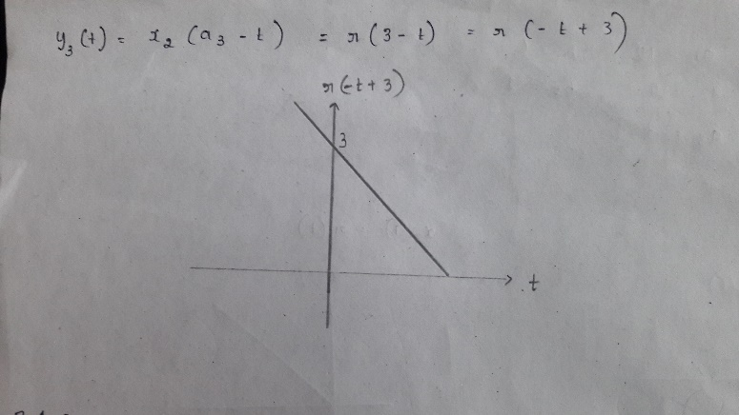

## B1.3 Compute and plot the signal 𝑦4(𝑡):

**Program:**

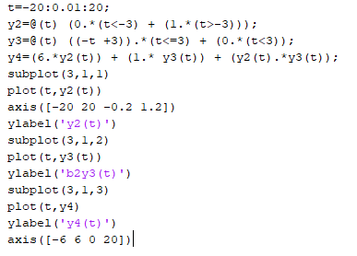

**Graph:**

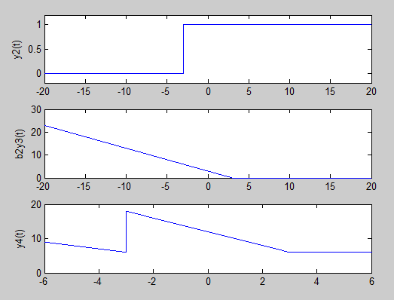

**For verification purpose:**

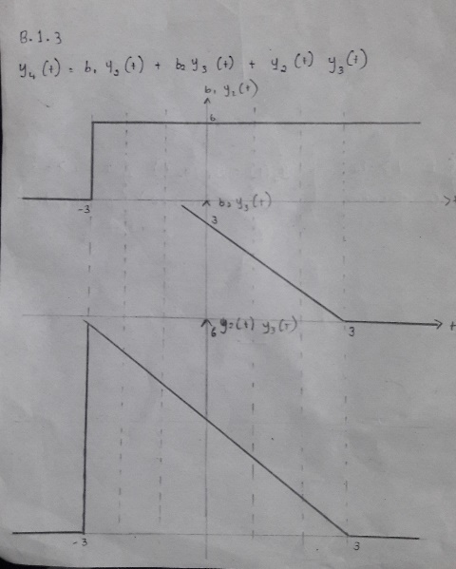

## 2.4 Conclusions

Students are expected to draw conclusions based on the discussions and suggestions (not to exceed 100 words)

# **Question No. B2**

**Solution to Question No. B2:**

**Values: frequency= 30, m(t)min=-4, m(t)max=11, h(t)min=-4, h(t)max=6**

## B2.1 Compute and plot the modulated signal.:

Program:

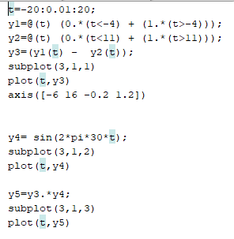

Graph plot:

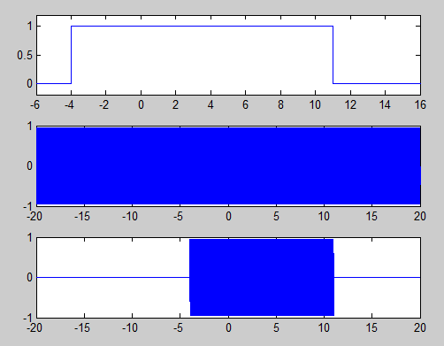

## B2.2 Compute and plot the received signal.:

Program:

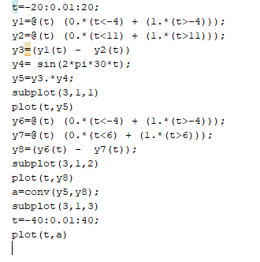

**Graph:**

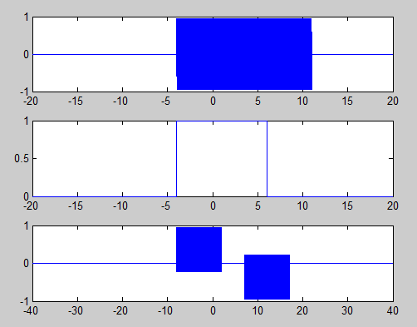

B2.3 Compare and comment on the energy of the message and received signals.